Boku Tile Selector Review

This document reviews the current Tile Selector (pie selector), listing good points and bad points. Further it will look at several other possible designs we have thought about over time.

# Goals

The following is a list of goals for the selector.

* All selections must be discoverable. Either directly visible or an obvious rollup is present.
* It uses the fewest actions to get at most selections. Click to open, stick to pick, click to select is best scenario.
* It uses either the stick or DPad for navigation and A button to select, and B button to cancel.
* Selection context is still present. Don’t obscure too much of the location that the selector was brought up from.
* Selector must be able to handle large set (we have a set of 46 today) but not an infinite set (greater than 1000) either directly or by logical grouping.
* The item “icon” (a model) is provided by the owner of the selector but selector provides the rest of the visualization.

# What we have

First, our current selector supports the ability to define a tree of items for the user to select. It displays them in a circle around the area of interest, while still showing the area interest. This was done due to the large number of items.

Below is displayed the root of one of the biggest selector trees. It represents 46 tiles, although only one is directly selectable at the root.

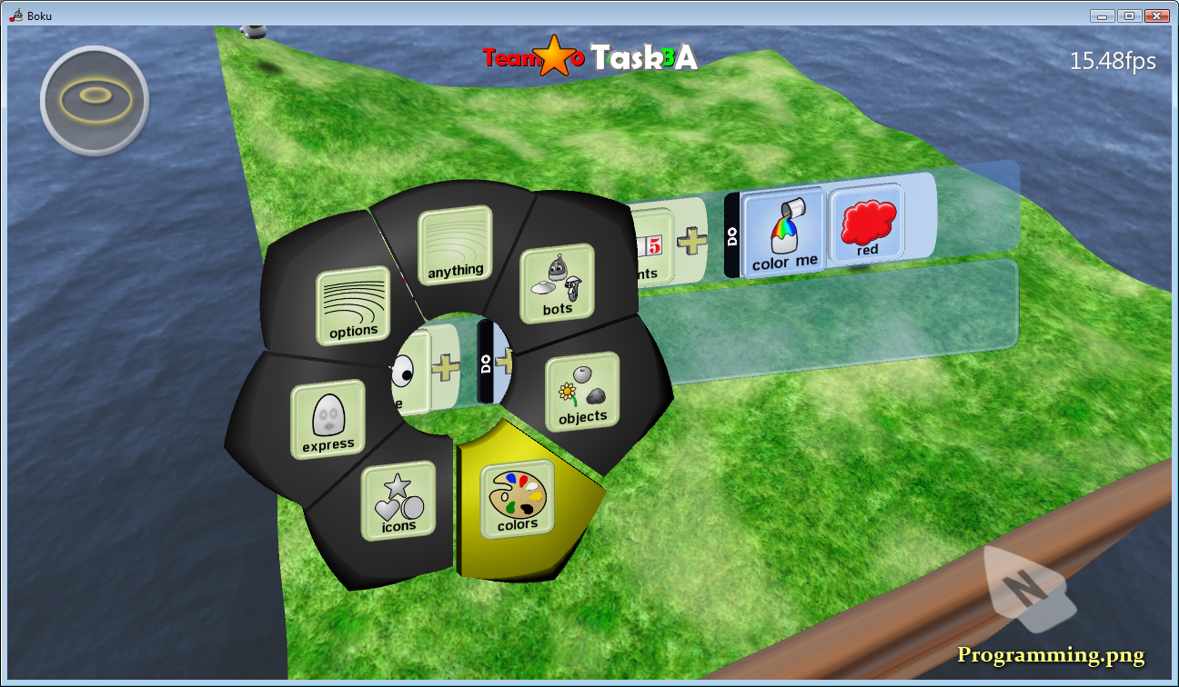

You can see the context through the center of the pie selector.

A group pedal has the pointy end. If the user selects it, it will open another selector with specific items to select. Only two levels are exposed to minimize the number actions to get to the item the user is looking for. After you have reached the second level, the context gets obstructed.

This model allows us to expose the high level choice (group) and then expose the specific selection. Most of the time it’s obvious which pedal to browse into. But in the example above we are near the limit of groups and items within the groups and a three depth selection maybe needed in the future if we continue to use it.

Further, the problem we will run into is that as the number of items within one level increases, the pie selection model becomes cumbersome; with a max number being around 10 and an optimal number being 8 or less. We have already had some complaints about the use of the stick but in general we have found that when instructed to push the stick and rotate it around, they find it functional. But this “technique” has not been obvious.

# A Simple Grid

One suggestion was to just drop to a simple grid of items. We would just have all them present in one view, maybe with a little visual clue as to related items. The user would navigate by move moving a cursor from item to item using the DPad or Stick. This would make all tiles discoverable; if not lost in the sea of tiles though. The input would be navigation across the grid and generally worse.

A mock up is shown below; and note that this is our current worst case set (filters) and the number could be larger in the future.

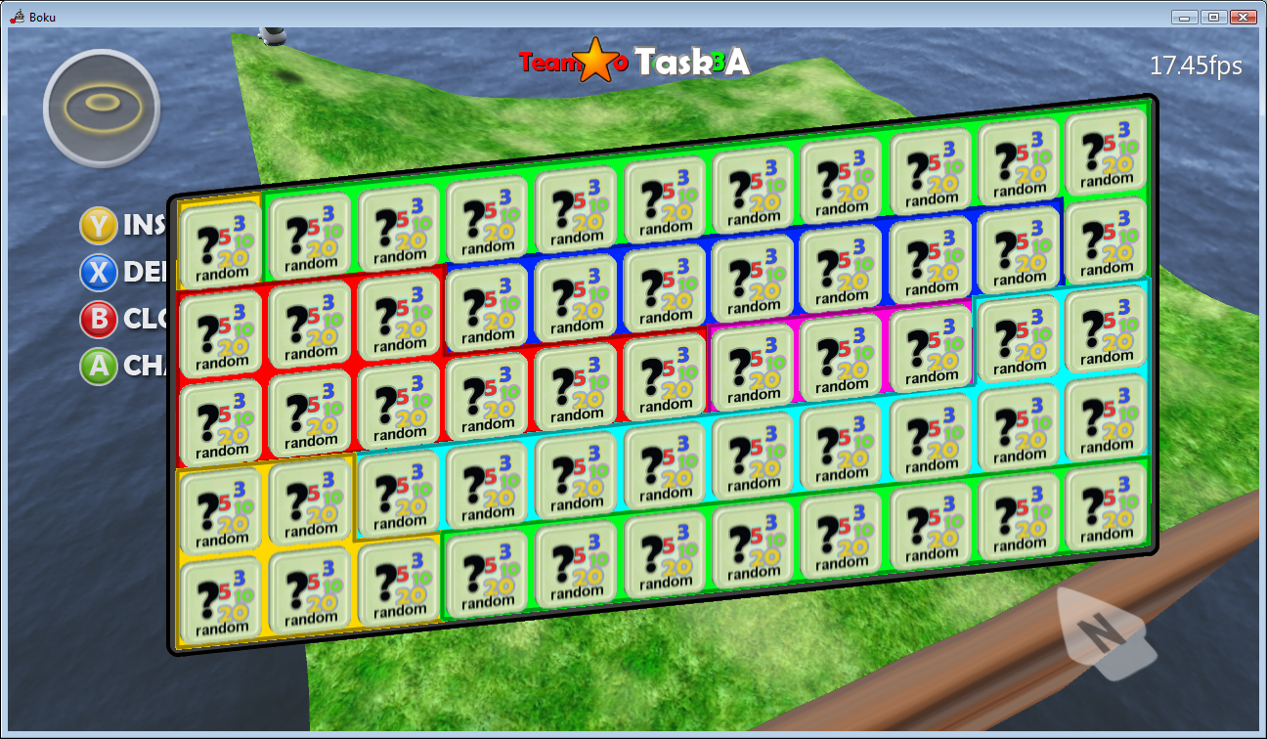

As you can see, the context of the selection is completely obscured. The number of tile options is overwhelming, even if associated into groups by a background color. The navigation from a centered item (or last selected) could be as high as 14 navigation actions with an average being near 4 navigation actions. But I suspect that navigation by the stick or DPad would be extremely easy to discover and use.

Below is simpler case of only two groups with normal amounts of items. This normal case is a lot less overwhelming but still obscures the context some.

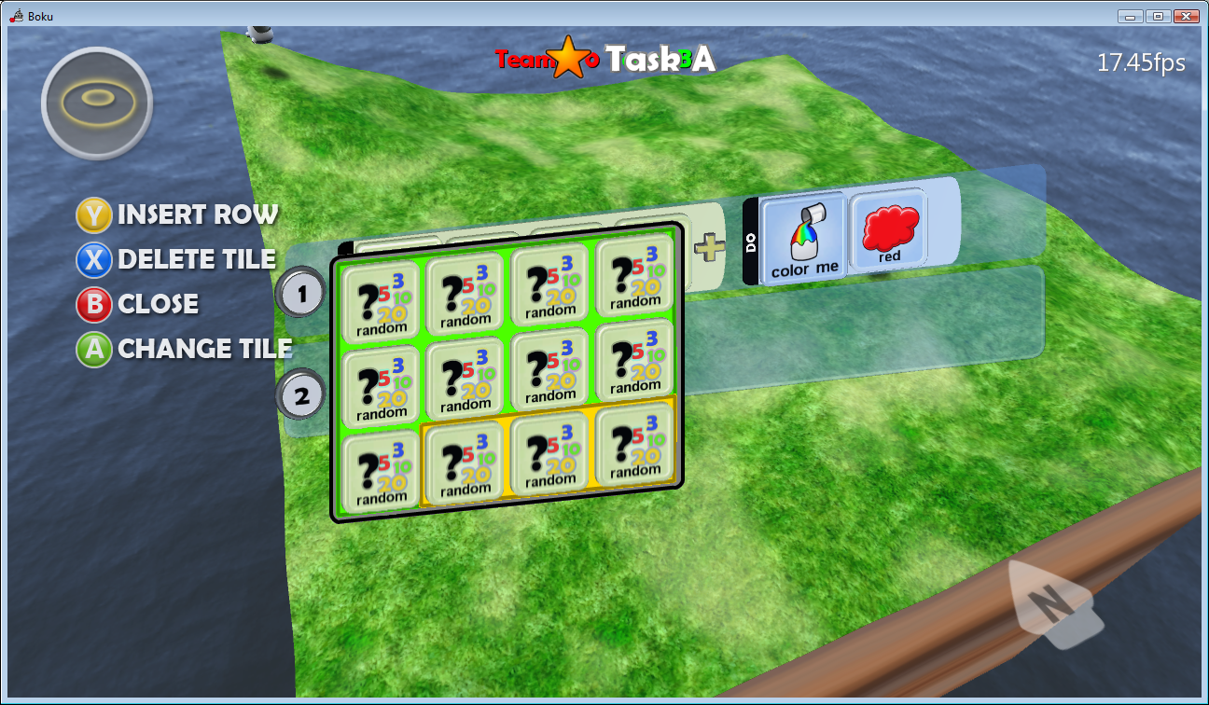

# Ribbon (dial) Selector

Another option is to use one axis of the grid to select the group, and the other axis to select the item in the group. This might work like our texture picker today. The below picture illustrates an example. The vertical strips are groups of items. So the left and right navigation would move between groups and the up and down would spin the group to see more items.

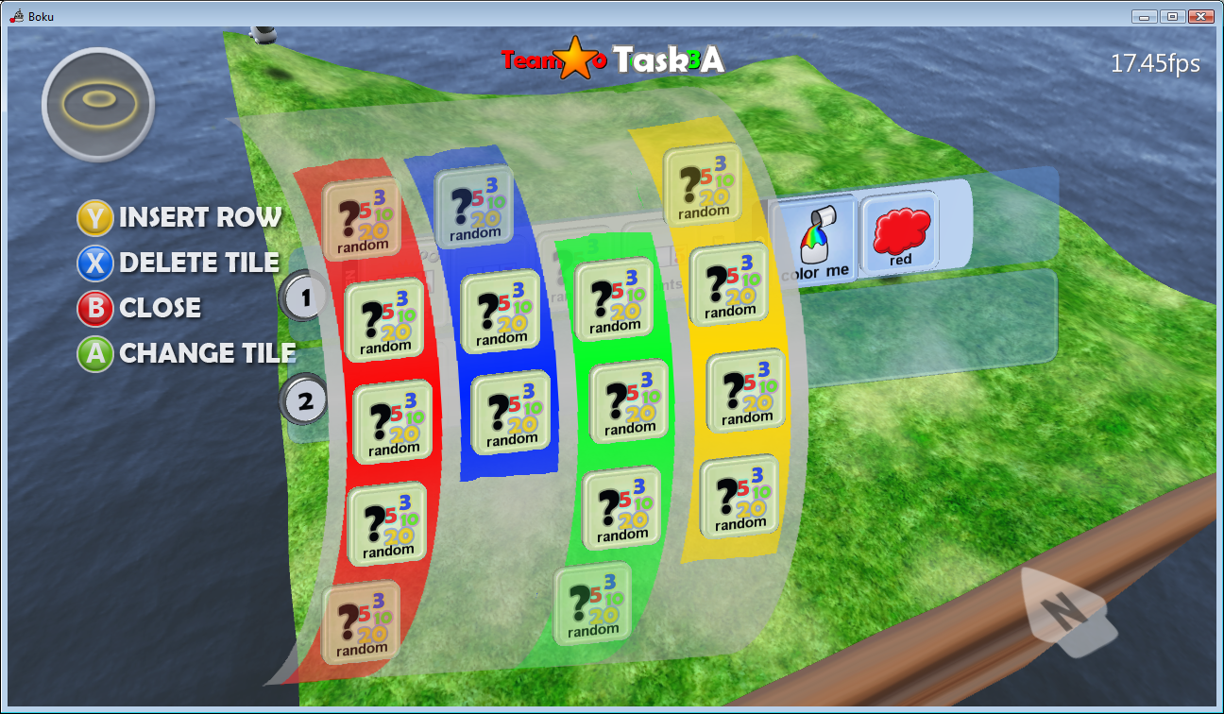

The illustration is simplified as an example, but you could image the items keeping the facing of the surface of the cylinder allowing a few more rows to be displayed; maybe even nine. Currently today, the largest set of items is the objects filters with 11 items. This same set is expected to grow and could be split up or just spin the items within the set into view.

It continues to have many of the same issues the grid layout does, but allows for faster navigation to group type before spinning to find the item of interest.